**HISTORIA CLÍNICA ORTODONCIA**

Ciudad Historia Clínica Nº

|  |  |  |
| --- | --- | --- |
|  |  |  |

Fecha

|  |  |  |
| --- | --- | --- |
|  |  |  |

1) **Datos Personales:**

Apellidos Nombres Edad Ocupación Teléfono

|  |  |  |  |  |
| --- | --- | --- | --- | --- |
|  |  |  |  |  |

Dirección Doc. Identidad Nombre familiar o responsable

|  |  |  |
| --- | --- | --- |
|  |  |  |

**2) Motivo de Consulta**

|  |
| --- |
|  |

**3) Anamnesis:**

* Tratamiento Médico ___  **\*** Enfermedades Respiratorias ___
* Toma medicamento ___ **\*** Enfermedades Cardiacas ___
* Cirugía ___  **\*** Enfermedades Endocrinas ___
* Diabetes ___  **\*** Enfermedades Trans. Sexual ___
* Hipertensión Arterial ___ **\*** Embarazo __________
* Alergias ___ **\*** Trauma o Accidente: ____
* Otras ___ * Respiración ______
* Masticación: Unilateral______Bilateral ______
* Higiene oral: _______________

Observaciones: ________________________________________________________

**4) Examen Extraoral**

* Perfil: _________
* Análisis de tercios: Sup________________ Med____________ Inf_____________
* Labio superior: Proquelia:_____ Retroquelia___ Normal_____
* Labio inferior: Proquelia:______ Retroquelia:____ Normal____
* Arco de sonrisa: Consonante:______ No consonante:_____
* Tipo de sonrisa: Normal____ Gingival____ Senil o baja:_____
* Línea media facial: Coincidente___ No coincidente______
* Análisis frontal_________________ * Selle labial_______________________
* Maxilar_________________ * Mandíbula_______________

**5) Examen Intraoral (Esto va igual en un modulo aparte)**

|  |  |  |
| --- | --- | --- |
| **Oclusión de frente** | **Oclusión Derecha** | **Oclusión Izquierda** |
| Línea Media: | Clase Canina: | Clase Canina: |
| Plano oclusal: | Clase Molar: | Clase Molar: |
| Malposición: | Malposición: | Malposición: |
| Overjet: | Overjet: | Overjet: |
| Overbite: | Overbite: | Overbite: |
| Sonrisa: | Curva de Spee: | Curva de Spee: |
| Otros: | Otros: | Otros: |

**6) Análisis Radiográfico( pero agregar modulo de Hallazgo)**

Radiografía Hallazgos

|  |  |
| --- | --- |
| Panorámica |  |
| Cefálica |  |
| Periapical |  |

**6) Odontograma (No va odontograma, colocar una selección para un plan unico de tratamiento)**

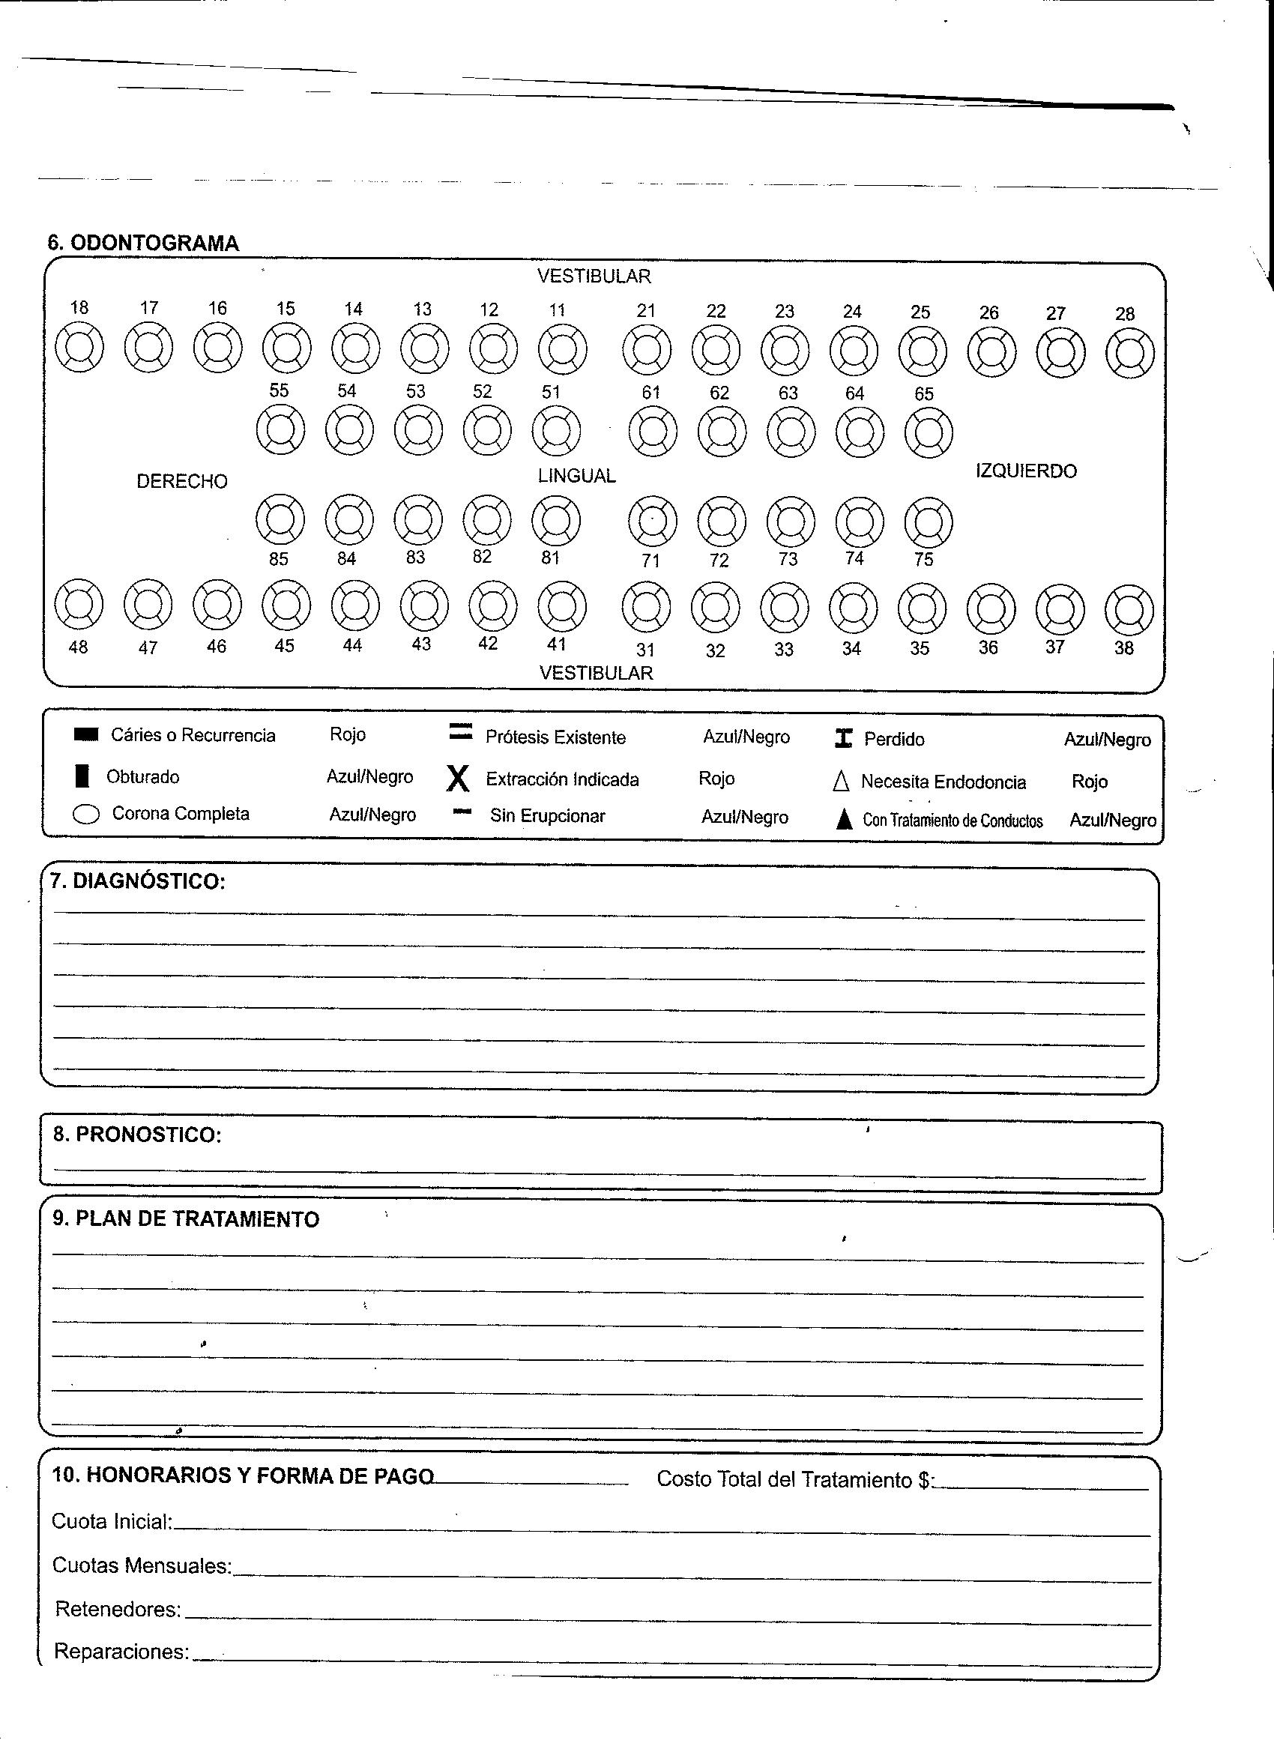

**7) Diagnostico (Esto va en un modulo aparte)**

Funcional:_____________________________________________________________Facial:_________________________________________________________________Esqueletico:___________________________________________________________

Dental: ____________________________________________________________________________________________

**8) Plan de tratamiento**

Ideal__________________________________________________________________

Real_________________________________________________________________________________________________________________________________________

___________________________________________________________________________________________________________________________________________

**9) Honorarios y Forma de pago**

|  |  |  |  |  |
| --- | --- | --- | --- | --- |
| Cuota Inicial | Controles | Reparación | Aparatología extra | Retenedores |
|  |  |  |  |  |

**10) Evolución**

|  |  |  |  |  |  |  |  |  |
| --- | --- | --- | --- | --- | --- | --- | --- | --- |
| Fecha | Tratamiento Realizado | | | | Abono | Debe | | Firma |
|  |  | | | |  |  | |  |
|  |  | | | |  |  | |  |
|  |  | | | |  |  | |  |
|  |  | | | |  |  | |  |
|  |  | | | |  |  | |  |
|  |  | | | |  |  | |  |
|  |  | | | |  |  | |  |
|  |  | | | |  |  | |  |
|  |  | | | |  |  | |  |
|  |  | | | |  |  | |  |
|  |  | | | |  |  | |  |
|  |  | | | |  |  | |  |
|  |  | | | |  |  | |  |
|  |  | | | |  |  | |  |
|  |  | | | |  |  | |  |
|  |  | | | |  |  | |  |
|  |  | | | |  |  | |  |
|  |  | | | |  |  | |  |
|  |  | | | |  |  | |  |
|  |  | | | |  |  | |  |
|  |  | | | |  |  | |  |
|  | |  |  |  | | |  | |
|  | |  |  |  | | |  | |
|  | |  |  |  | | |  | |
|  | |  |  |  | | |  | |
|  | |  |  |  | | |  | |
|  | |  |  |  | | |  | |
|  | |  |  |  | | |  | |
|  | |  |  |  | | |  | |
|  | |  |  |  | | |  | |
|  | |  |  |  | | |  | |
|  | |  |  |  | | |  | |
|  | |  |  |  | | |  | |
|  | |  |  |  | | |  | |
|  | |  |  |  | | |  | |
|  | |  |  |  | | |  | |
|  | |  |  |  | | |  | |
|  | |  |  |  | | |  | |
|  | |  |  |  | | |  | |
|  | |  |  |  | | |  | |
|  | |  |  |  | | |  | |
|  | |  |  |  | | |  | |
|  | |  |  |  | | |  | |
|  | |  |  |  | | |  | |
|  | |  |  |  | | |  | |
|  | |  |  |  | | |  | |
|  | |  |  |  | | |  | |
|  | |  |  |  | | |  | |
|  | |  |  |  | | |  | |
|  | |  |  |  | | |  | |
|  | |  |  |  | | |  | |
|  | |  |  |  | | |  | |
|  | |  |  |  | | |  | |